Things in:
[-] is the guidance section for each specification point from the specification
#-# are from the content exemplification for enhanced content guidance (not in specification but from another document which clarify some specification points)

Calculator guide for mechanics playlist - https://www.youtube.com/playlist?list=PLd7FwnU6nvjHOsBSD7SnnjYGGVBdiyQDg

AS Level

6.0 Quantities and units in mechanics

6.1 Understand and use fundamental quantities and units in the S.I. system: length, time, mass. Understand and use derived quantities and units: velocity, acceleration, force, weight, [Students may be required to convert one unit into another e.g. km h-1 into m s-1 ]
How do you convert from km h-1 to ms-1 | - 1km/1h  - 1000m/3600s

7 Kinematics

7.1 Understand and use the language of kinematics: position; displacement; distance travelled; velocity; speed; acceleration.

[Students should know that distance and speed must be positive.]

#Students should know the difference between distance and displacement.#

7.2 Understand, use and interpret graphs in kinematics for motion in a straight line: displacement against time and interpretation of gradient; velocity against time and interpretation of gradient and area under the graph.

[Graphical solutions to problems may be required. ]

# Speed-time graphs may also be required.#
Suggest one further refinement to the model for the parachutist, apart from air resistance, to make the  model more realistic.  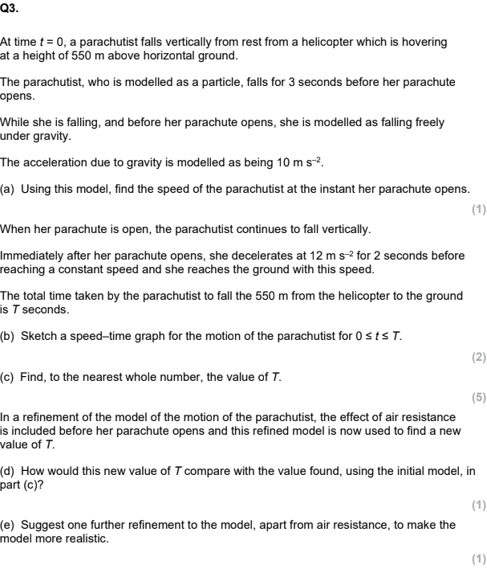 | - Use a more accurate value for g (Use this for most questions)  - Allow for dimensions of parachutist  - Parachutist does not fall vertically after chute opens  - Effect of wind  - Smooth changes in v  - Time for parachute to open  - Deceleration not constant  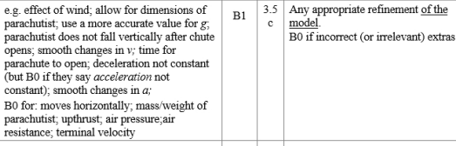

7.3 Understand, use and derive the formulae for constant acceleration for motion in a straight line.

[Derivation may use knowledge of sections 7.2 and/or 7.4]

#Problems involving vertical motion under gravity could be set.#
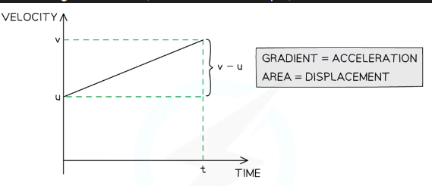 | 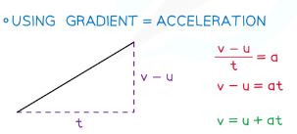  - dy/dx = V-u/t = a
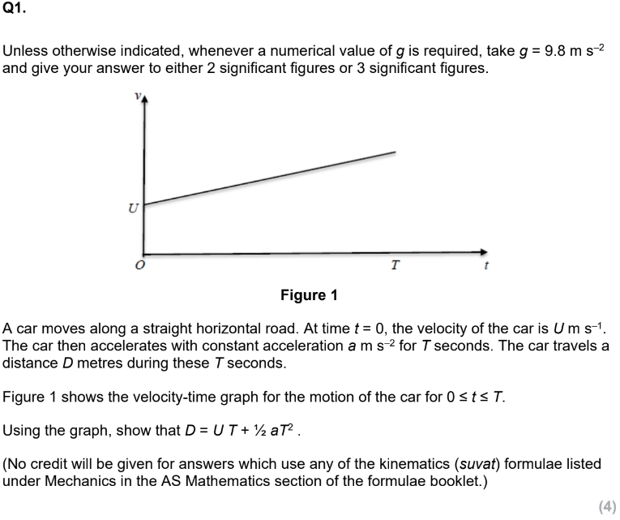  Using the graph,show that D=UT+0.5aT² | 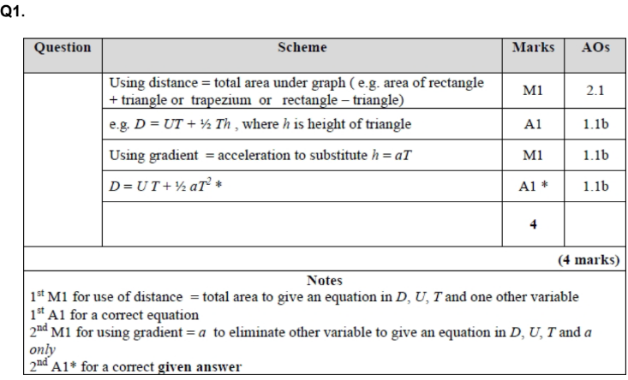  - Distance = total area under graph (i.e. area of rectangle + triangle or trapezium or rectangle - triangle)  - D = UT + 0.5Th  - Where h is height of triangle  - Using gradient = acceleration sub in h=aT  - D = UT + 0.5aT²
Using calculus derive v = u+at | - Velocity = ∫acceleration dt  - Velocity = ∫a dt = at + c  - When t = 0, velocity = u  - u = a(0) + c  - u = c  - At time = t, velocity = v  - v = u+at
Using calculus derive s=ut +0.5at² | - Displacement = ∫(Velocity) dt  - Displacement = ∫v dt = ∫(u+at) dt = ut + 0.5at² + c  - t = 0, displacement = 0  - 0 = u(0) + 0.5a(0)² + c  - c = 0  - S = ut+0.5at²
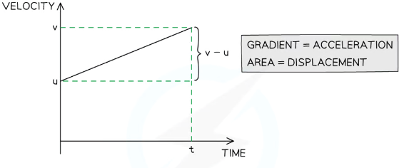 | 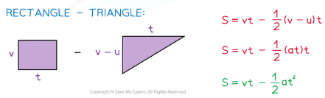
 | 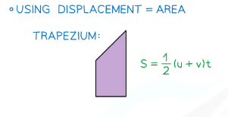
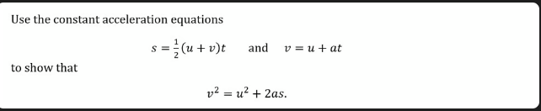 | 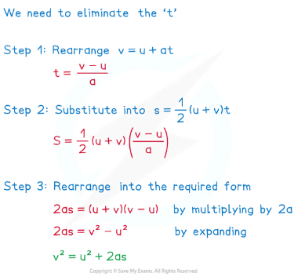

7.4 Use calculus in kinematics for motion in a straight line: $V=\frac{dr}{dt}$, $a =\frac{dv}{dt}=\frac{d^{2}r}{dt^{2}}$, r =$\int{}v dt$, r = $\int{}a dt$

[The level of calculus required will be consistent with that in Sections 7 and 8 in the Pure Mathematics content.]

#For example, given the distance of a particle P, which is moving in a straight line, from a point O at time t, find when: (a) P is at rest, (b) P stops accelerating.#

8 Forces & Newton’s Laws

8.1 Understand the concept of a force; understand and use Newton’s first law.

[Normal reaction, tension, thrust or compression, resistance.]

8.2 Understand and use Newton’s second law for motion in a straight line (restricted to forces in two perpendicular directions or simple cases of forces given as 2-D vectors);

[Problems will involve motion in a straight line with constant acceleration in scalar form, where the forces act either parallel or perpendicular to the motion. Problems may involve motion in a straight line with constant acceleration in vector form, where the forces are given in i − j form or as column vectors.]

#For example, find the magnitude of the acceleration when the forces are given as vectors.#

8.3 Understand and use weight and motion in a straight line under gravity; gravitational acceleration, g, and its value in S.I. units to varying degrees of accuracy. (The inverse square law for gravitation is not required and g may be assumed to be constant, but students should be aware that g is not a universal constant but depends on location.)

[The default value of g will be 9.8 m s−2 but some questions may specify another value, e.g. g = 10 m s−2]

8.4 Understand and use Newton’s third law; equilibrium of forces on a particle and motion in a straight line (restricted to forces in two perpendicular directions or simple cases of forces given as 2-D vectors); application to problems involving smooth pulleys and connected particles;

[Connected particle problems could include problems with particles in contact e.g. lift problems.]

#For example, problems involving particles connected by a string which passes over a pulley, where either, both particles are moving vertically, or one is moving vertically and the other is moving horizontally. Students may be required to find the magnitude and direction of the force acting on the pulley. Students should be aware of the modelling assumptions, and the reasons why they are made, when considering pulley systems. For example, a light and inextensible string, a smooth and light pulley.#
What is the model Particle and what are its modelling assumptions? | - Dimensions of the object are negligible  - Mass of the object is concentrated at a single point  - Rotational forces and air resistance can be ignored
What is the model Rod and what are its modelling assumptions? | - All dimensions but one are negligible, like a pole or a beam  - Mass is concentrated alone a line  - No thickness  - Rigid (does not bend or buckle)
What is the model Lamina and what are its modelling assumptions? | - Object with area but negligible thickness, like a sheet of paper  - Mass is distributed across a flat surface
What is the model Unform body and what are its modelling assumptions? | - Mass is distributed  - Mass of the object is concentrated at a single point at the geometrical centre of the body - the centre of mass
What is the model Light object and what are its modelling assumptions? | - Mass of the object is small compared to other masses, like a string or a pulley  - Treat object as having 0 mass  - Tension the same at both ends of a light string
What is the model inextensible string and what are its modelling assumptions? | - A string that does not stretch under load  - Acceleration is the same in objects connected by a taut inextensible string
What is the model Smooth surface modelling assumptions? | - Assume that there is no friction between the surface and any object on it
What is the model Rough surface and what are its modelling assumptions? | - If a surface is not smooth, it is rough  - Objects in contact with the surface experience a frictional force
What is the model Wire and what are its modelling assumptions? | - Rigid thin length of metal  - Treated as 1 dimensional
What is the model Smooth and light pulley and what are its modelling assumptions? | - All pulleys you consider will be smooth and light  - Pulley has no mass  - Tension is the same on either side of the pulley
What is the model Bead and what are its modelling assumptions? | - Particle with a hole in it for threading on a wire or string  - Moves freely along a wire or string  - Tension is the same on either side of the bead
What is the model Peg and what are its modelling assumptions? | - A support from which a body can be suspended or rested  - Dimensionless and fixed  - Can be rough or smooth as specified in question
What is the model Air resistance and what are its modelling assumptions? | - Resistance experienced as an object moves through the air  - Usually modelled as being negligible
What is the model Gravity and what are its modelling assumptions? | - Force of attraction between all objects. A acceleration due to gravity is denoted to g  - Assume that all objects with mass are attracted towards the Earth  - Earth’s gravity is uniform and acts vertically downwards  - g is constant is takes as 9.8ms-2, unless otherwise stated in the quesiton

A LEVEL

6.0 Quantities and units in mechanics

6.1 Understand and use derived quantities and units: MOMENTS #Students should appreciate that there are equivalent units; for example, N s and kg m s–1 for impulse (or momentum).#
In mechanics physics flashcards | Nm/Ncm

7 Kinematics

7.3 Extend to 2 dimensions using vectors

[Understand and use suvat (or ruvat) formulae for constant acceleration in 2-D, e.g. v = u + at , r = ut + 0.5at² at with vectors given in i − j or column vector form. Use vectors to solve problems.]

7.4 Extend to 2 dimensions using vectors.

[Differentiation and integration of a vector with respect to time. E.g. Given r = t²i + t²j, find r. and r.. at a given time.]

#For example, given the position vector of a particle, r, at time t, find the time when it is moving in a given direction.#

7.5 Model motion under gravity in a vertical plane using vectors; projectiles.

[Derivation of formulae for time of flight, range and greatest height and the derivation of the equation of the path of a projectile may be required.]

#Students may be required to use the equation of the path, for example to determine the required projection angle(s) to hit a given target using a given projection speed. Students should be aware of the modelling assumptions being made when modelling motion under gravity.#
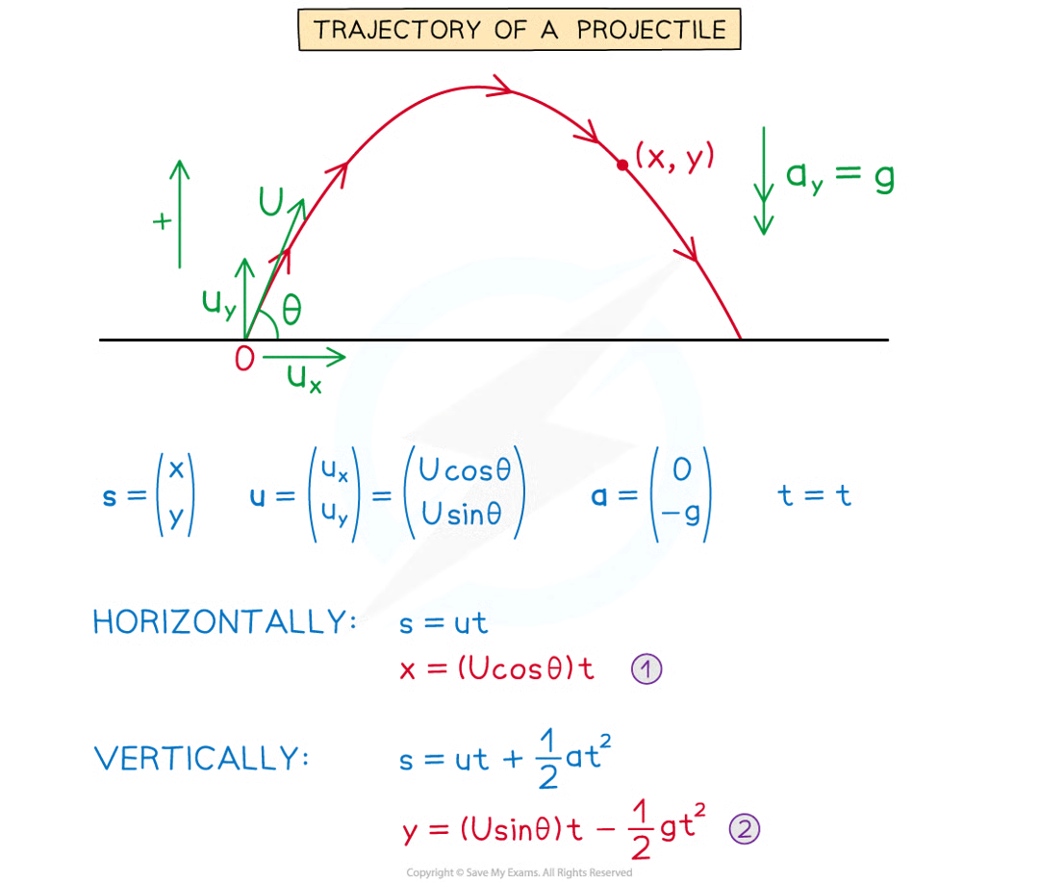
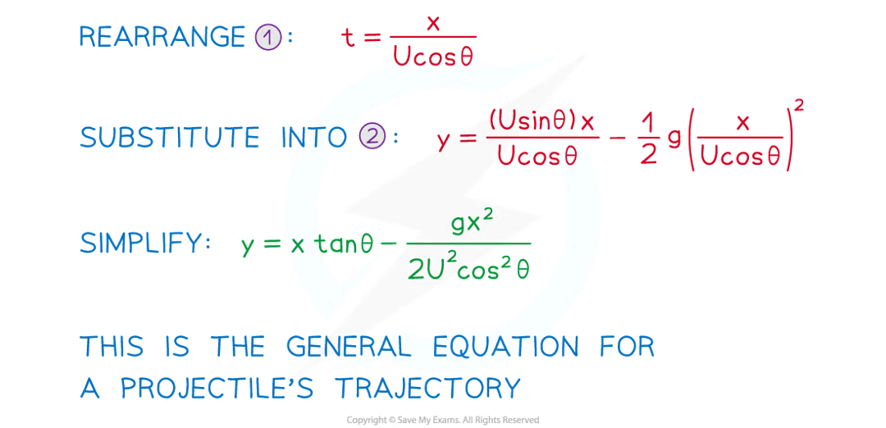

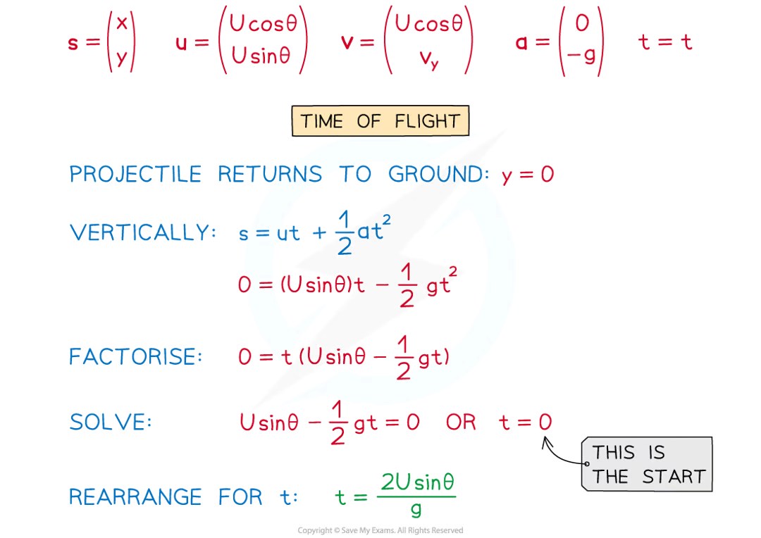
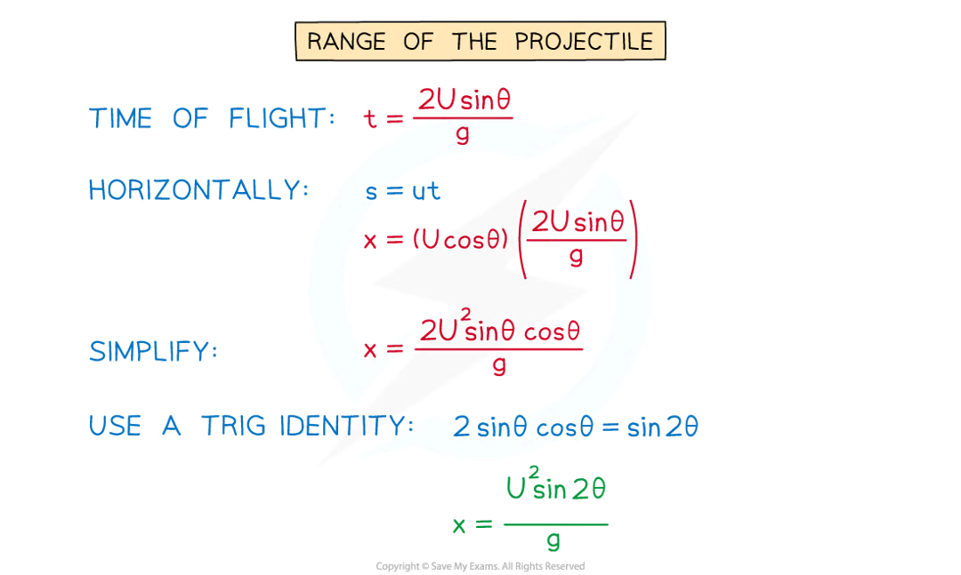
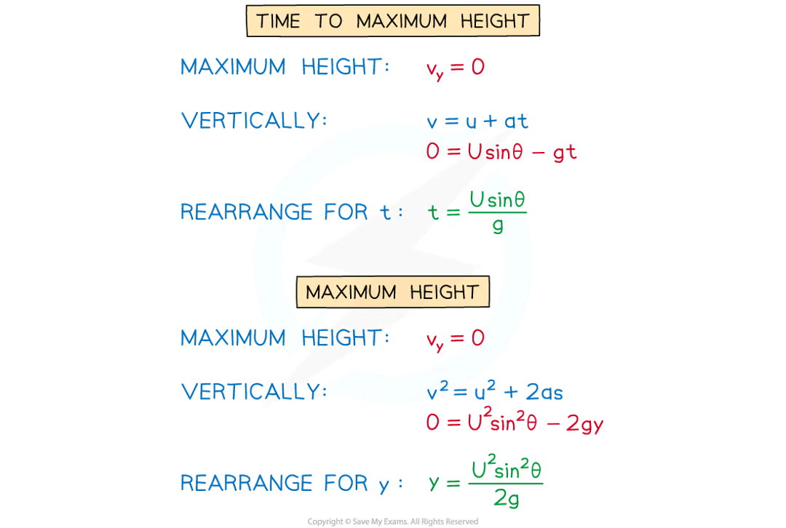

8 Forces & Newton’s Laws

8.2 Extend to situations where forces need to be resolved (restricted to 2 dimensions).

[Extend to problems where forces need to be resolved, e.g. a particle moving on an inclined plane.]

#For example, find the acceleration of a particle moving on an inclined plane.#

8.4 Resolving forces in 2 dimensions; equilibrium of a particle under coplanar forces.

[Problems may be set where forces need to be resolved, e.g. at least one of the particles is moving on an inclined plane.

#For example, problems involving particles connected by a string which passes over a pulley, where at least one of the particles is moving on an inclined plane.#

8.5 Understand and use addition of forces; resultant forces; dynamics for motion in a plane.

[Students may be required to resolve a vector into two components or use a vector diagram, e.g. problems involving two or more forces, given in magnitude- direction form.]

#For example, finding the magnitude and direction of the resultant of two or more forces which are given in magnitude–direction form.#

8.6 Understand and use the F ≤ μR model for friction; coefficient of friction; motion of a body on a rough surface; limiting friction and statics.

[ An understanding of F = μR when a particle is moving. An understanding of F ≤ μR in a situation of equilibrium.]

#Students should know the difference between reaction and normal reaction and when they are different. Problems may be set involving a particle in limiting equilibrium.#

9 Moments

9.1 Understand and use moments in simple static contexts.

[Equilibrium of rigid bodies. Problems involving parallel and non- parallel coplanar forces, e.g. ladder problems. ]

#Examples may include situations where students are required to calculate an unknown force or an unknown coefficient of friction. Problems may include: • a ladder with one end on rough ground leaning against a rough wall • a rod with one end on rough ground and resting against a rough cylinder or a peg.#

